THE DIGITAL IMAGINARY

DBMS ASSIGNMENT-1

S. Bagawan Reddy

1602-21-737-012

IT-A

**Abstract:**

The E-learning project aims to provide a web-based platform for students to access course materials, take mock quizzes, track their progress, and to access question bank. The system includes a user table to manage user information. The system also includes a Progress table to track the user's progress in the course. It also includes the list of students who solved questions from question bank. This project provides a comprehensive solution for online learning, which is especially relevant in the current context where remote learning is becoming more popular. It allows users to learn at their own pace and provides tools to track their progress and improve their learning outcomes.

**Requirements:**

Tables that I have identified are: Students, Notes, Mock Quiz, Questions, Scores.

**1.Students Table:**

|  |  |  |
| --- | --- | --- |
| Attribute | Domain | CONSTARINT |
| Student_id | NUMBER | Primary_Key |
| Student_name | VARCHAR | Not Null |
| Class | VARCHAR |  |
| Password | VARCHAR | Not Null |

**2.Notes Table:**

|  |  |  |
| --- | --- | --- |
| Attribute | Domain | CONSTRAINT |
| Chapter_no | NUMBER | Primary_Key |
| Chapter_name | VARCHAR | Not Null |

|  |  |  |
| --- | --- | --- |
| Attribute | Domain | Constraint |
| Quiz_id | NUMBER | Primary_Key |
| Duration | TIME |  |

**3.Mock_Quiz:**

**4.Questions:**

|  |  |  |
| --- | --- | --- |
| Attribute | Domain | CONSTRAINT |
| Question_no | NUMBER | Primary_Key |
| Question | VARCHAR | Not Null |

**5.Scores:**

|  |  |  |
| --- | --- | --- |
| Attribute | Domain | CONSTARINT |
| Student_id | NUMBER | Foreign_Key |
| Quiz_id | NUMBER | Foreign_Key |
| Marks | NUMBER | Not Null |

**ER Diagram:**

All the relations are Many to Many relations.

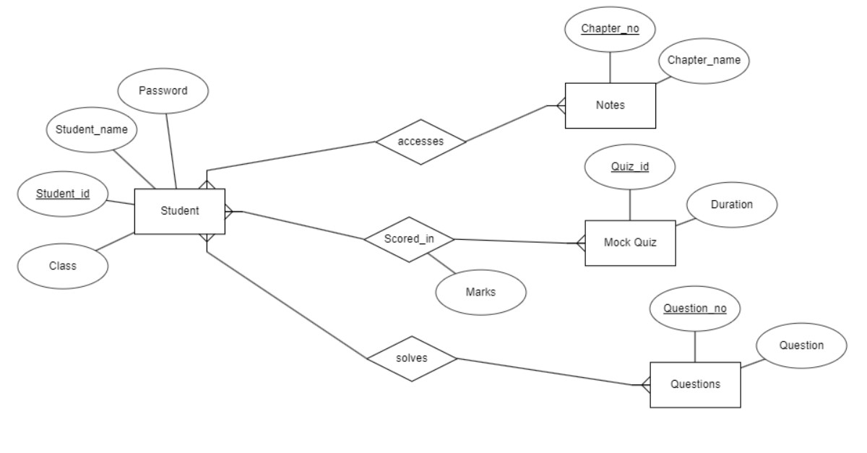

**DDL COMMANDS:**

1.Creating table for students with constraints :

**QUERY:** create table students(

2 student_id number(4),

3 student_name varchar(20),

4 class varchar(5),

5 password varchar(15),

6 primary key(student_id));

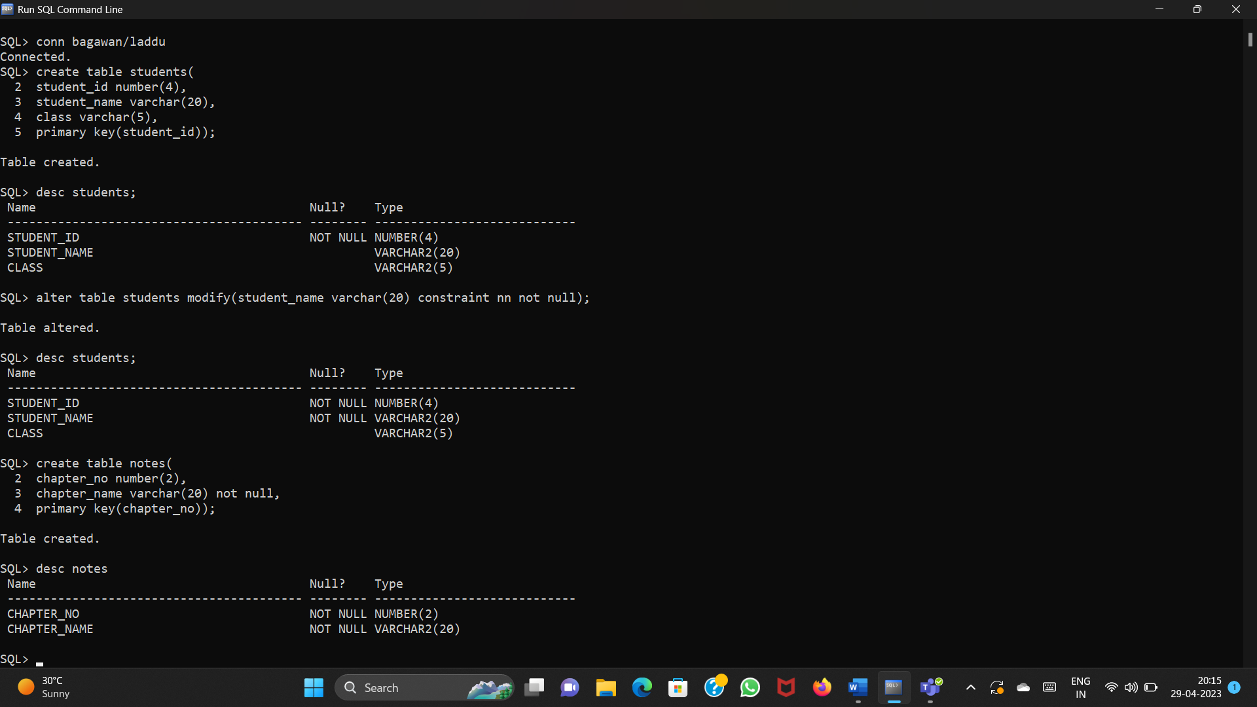

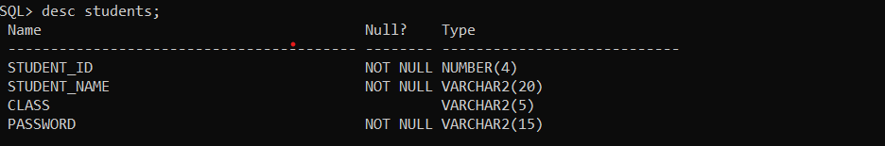

2. Creating notes table:

**QUERY:** create table notes(

2 chapter_no number(2),

3 chapter_name varchar(20) not null,

4 primary key(chapter_no));



3.Creating mock_quiz table:

**QUERY:** create table mock_quiz(

2 quiz_id number(4) primary key,

3 duration varchar(10));

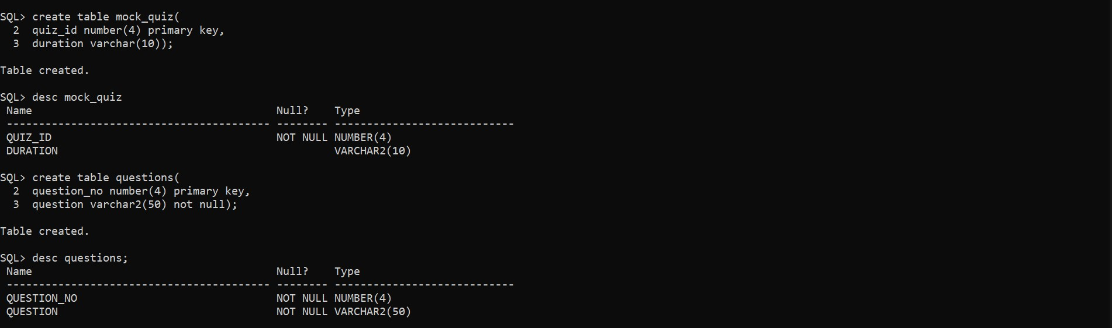

4.Creating Questions table:

**QUERY:** create table questions(

2 question_no number(4) primary key,

3 question varchar2(50) not null);



5.Creating scores table:

**QUERY:** create table scores(

2 student_id number(4),

3 quiz_id number(4),

4 marks number(3),

5 foreign key(student_id) references students,

6 foreign key(quiz_id) references mock_quiz);

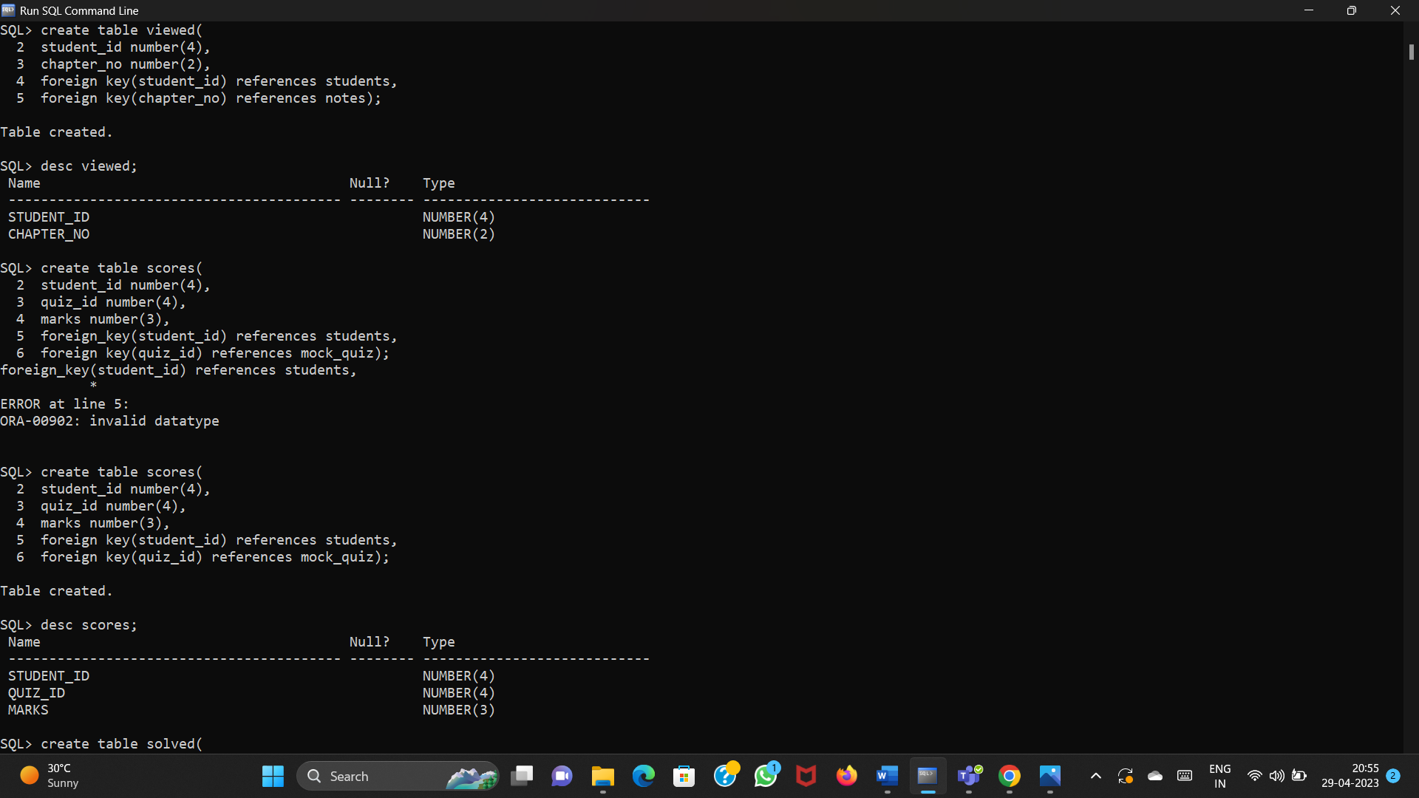

**DML COMMANDS:**

1.Insert values into students:

**QUERY:** insert into students values(&student_id,'&student_name','&class',’&password’);

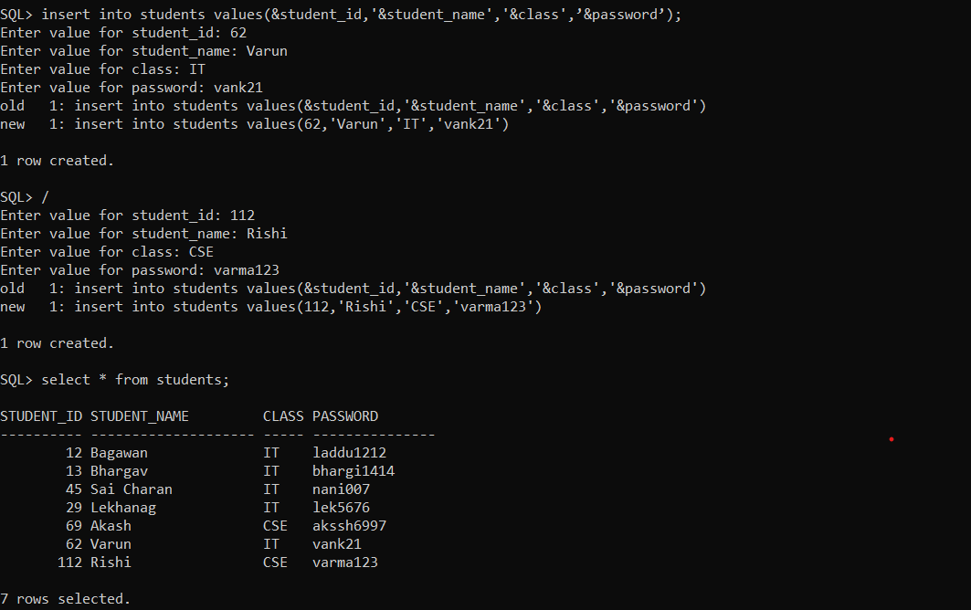

2.Insert values into notes:

**QUERY:** insert into notes values(&chapter_no,'&chapter_name');

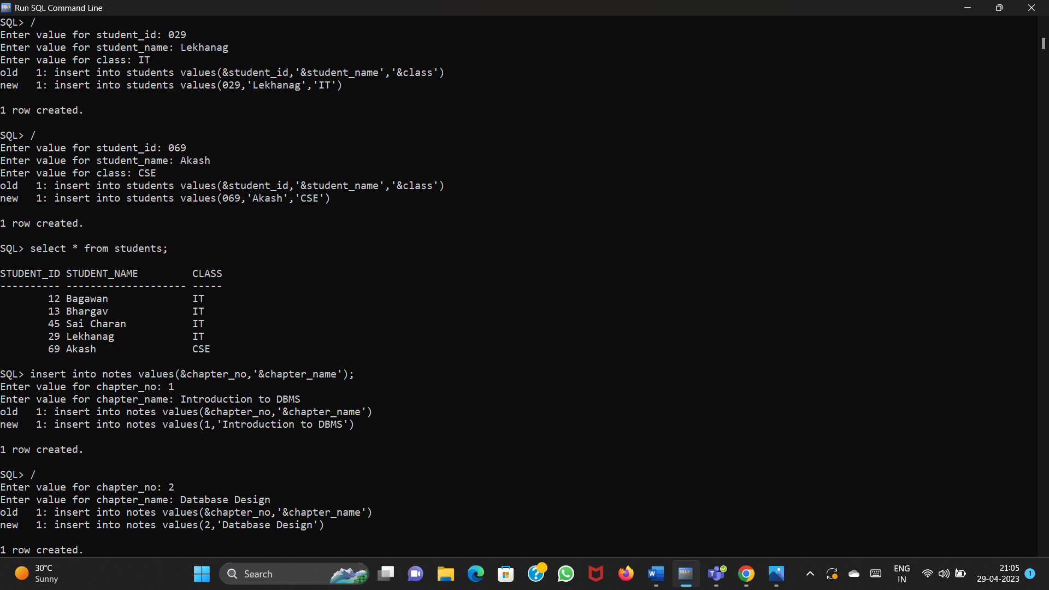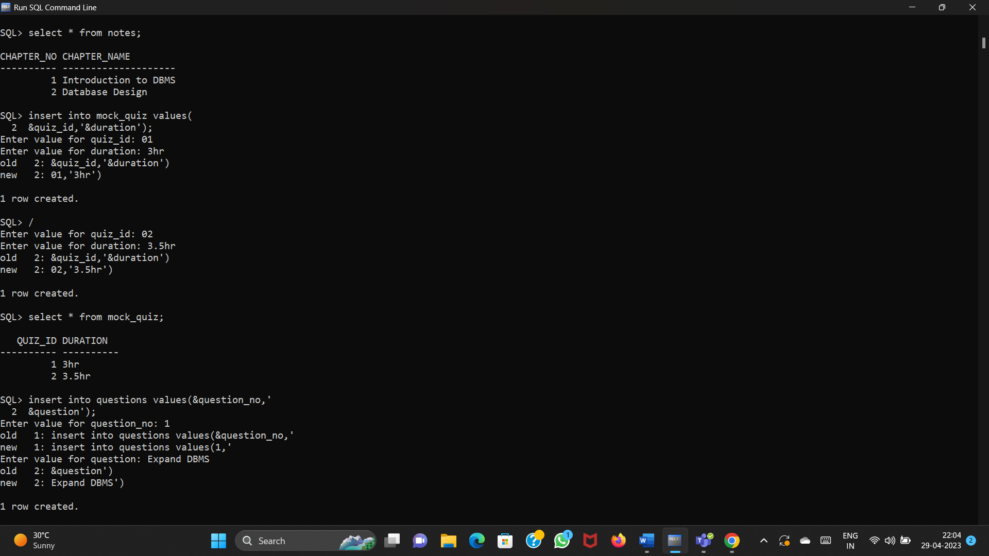

3.Insert values into mock_quiz:

**QUERY:** insert into mock_quiz values(

2 &quiz_id,'&duration');

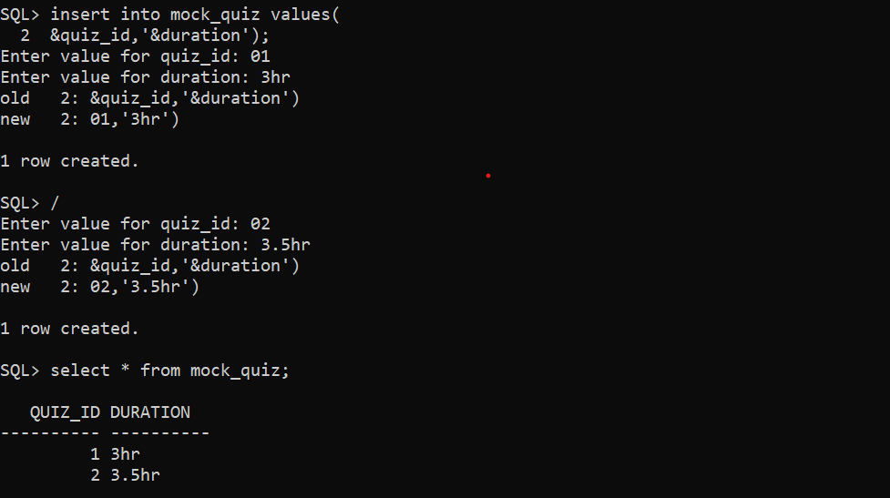

4.Insert values into questions:

**QUERY:** insert into questions values(&question_no,'&question');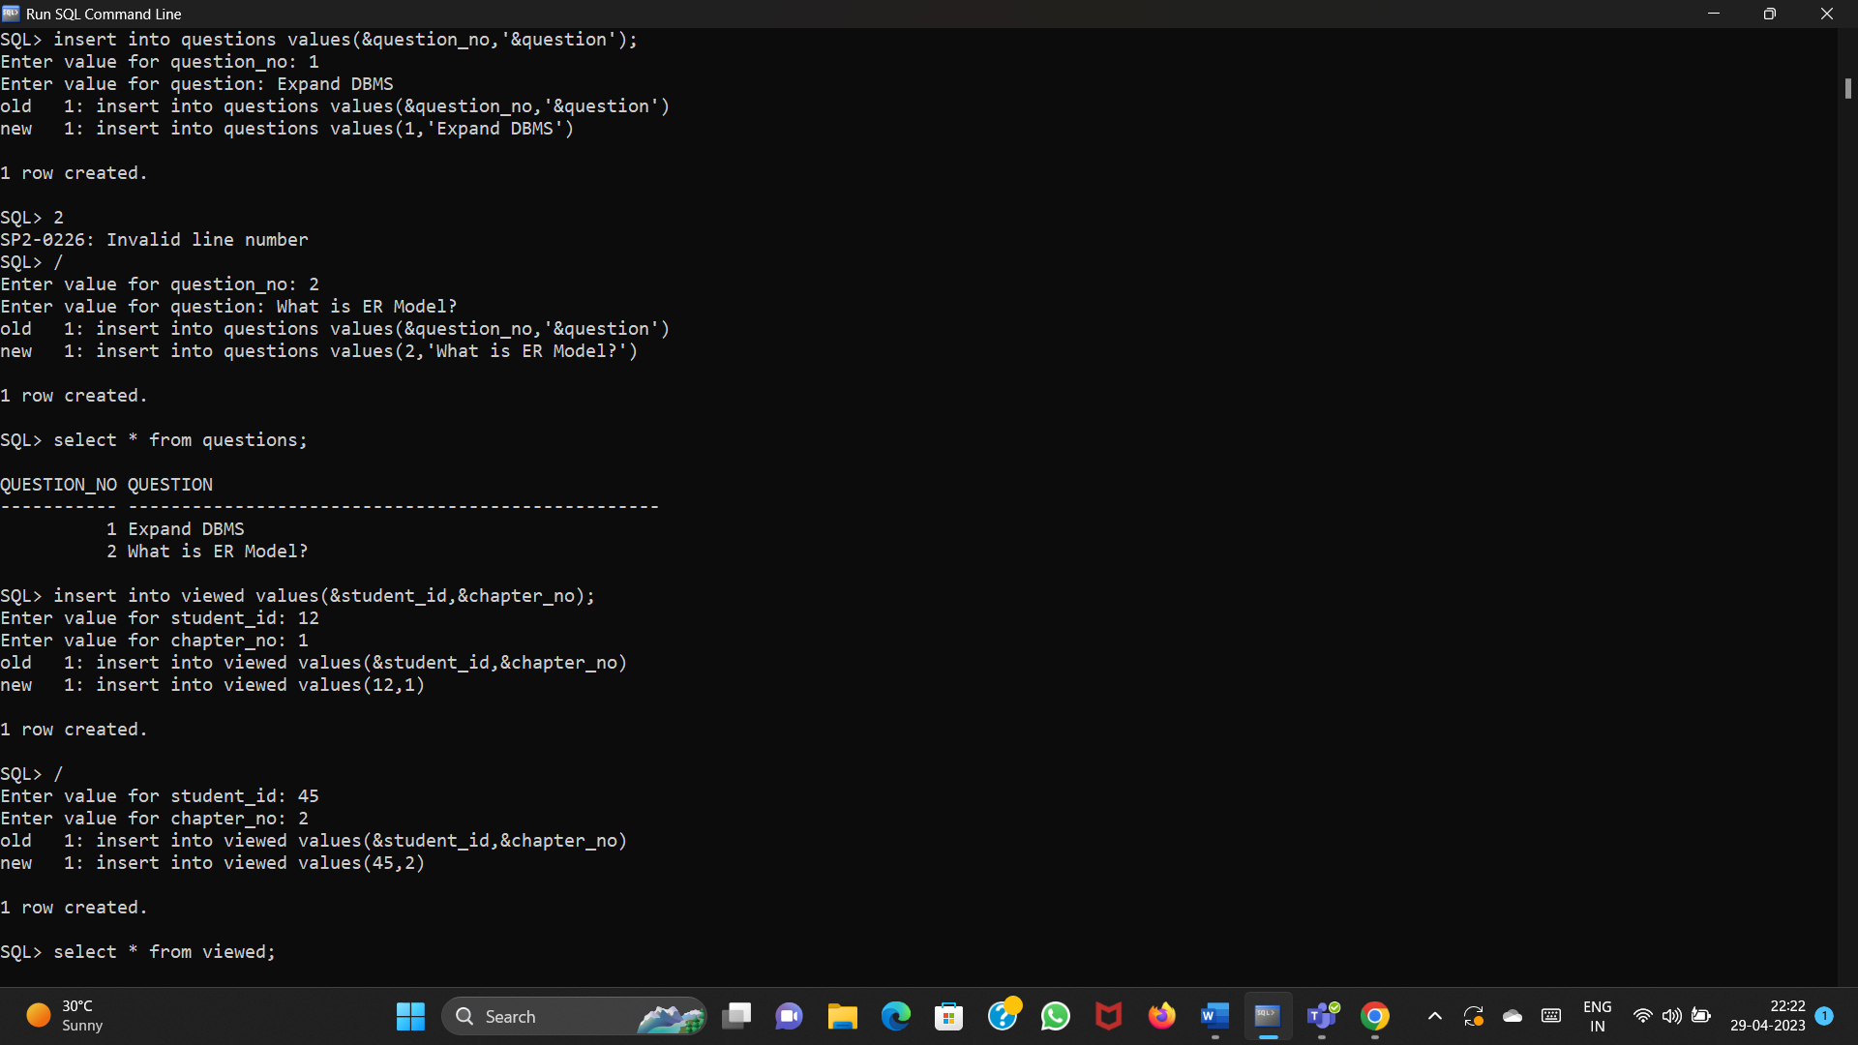

5.Insert values into scores:

**QUERY:** insert into scores values(&student_id,&quiz_id,&marks);

